Carrwood Primary School
Art LTP
 | Autumn 1 | Autumn 2 | Spring 1 | Spring 2 | Summer 1 | Summer 2
Petals | These activities happen all year round and allow for opportunities both indoors and our doors.  Start to make marks intentionally. (Development Matters, 0-3Y)  Drawing and Painting - Begins to use different medias to explore mark making. Paint, Chalk, crayon, whiteboard pens, felt-tip pens and pencils.  Begins to use glue and make a simple collage picture.  Explore paint, using fingers and other parts of their bodies as well as brushes and other tools. (Development Matters, 0-3Y) Painting and mixed media  Make simple models which express their ideas.  (Development Matters, 0-3Y)  Sculpture and 3D  Express ideas and feelings through making marks, and sometimes give a meaning to the marks they make. (Development Matters, 0-3Y)
Nursery | Explore different materials freely, to develop their ideas about how to use them and what to make.  (Development Matters, 3-4Y)  Develop their own ideas and then decide which materials to use to express them.  (Development Matters, 3-4Y)  Join different materials and explore different textures.  (Development Matters, 3-4Y)  Painting and mixed media  Explores box modelling and making 3D creations.  (Development Matters, 3-4Y)  Sculpture and 3D |  | Create closed shapes with continuous lines and begin to use these shapes to represent objects.  (Development Matters, 3-4Y)  Draw with increasing complexity and detail, such as representing a face with a circle and including details.  (Development Matters, 3-4Y)  Use drawing to represent ideas.  (Development Matters, 3-4Y)  Drawing |  | Show different emotions in their drawings and paintings, like happiness, sadness, fear, etc.  (Development Matters, 3-4Y)  Explore colour and colour mixing. - Mix powder paint to make different colours.  (Development Matters, 3-4Y)  Show different emotions in their drawings – happiness, sadness, fear, etc (Development Matters, 3-4Y)  Drawing
Reception | To use colours purposefully - Explore, use and refine a variety of artistic effects to express their ideas and feelings.  (Development Matters, Reception) Painting and mixed media  Return to and build on their previous learning, refining ideas and developing their ability to represent them.  (Development Matters, Reception)  Painting and mixed media  Drawing |  | To mix primary colours for a planned outcome. - Explore, use and refine a variety of artistic effects to express their ideas and feelings.  (Development Matters, Reception)  Painting and mixed media  Design a boat that floats. - Create collaboratively, sharing ideas, resources and skills.  (Development Matters, Reception)  Sculpture and 3D  Craft and design |  | Use a range of methods to join materials together. - Return to and build on their previous learning, refining ideas and developing their ability to represent them.  (Development Matters, Reception)  Sculpture and 3D  Craft and design
Year 1 | 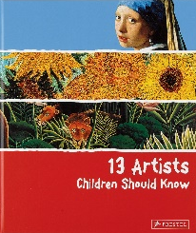  Exploring line and shape  Drawing and Painting  Line |  | 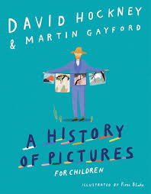  Paper play  Sculpture and 3D  Line |  | Colour splash  Painting and mixed media  Colour
Year 2 | Understanding tone and texture  Drawing  Texture |  | Life in colour  Painting and mixed media  Texture  Colour |  | Clay houses  Sculpture and 3D  Line
Year 3 | Developing drawing skills  Drawing  Line |  | Ancient Egyptian scrolls  Craft and design |  | Abstract shape and space  Sculpture and 3D  Line
Year 4 | Exploring tone, texture and proportion  Drawing  Line  Texture |  | Light and Dark  Painting and mixed media  Colour  Texture |  | Fabric of nature  Craft and design  Pattern
Year 5 | Interactive installation  Sculpture and 3D  Line  Pattern |  | 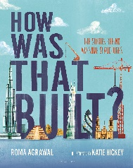  Depth, emotion and movement  Drawing  Line  Texture |  | 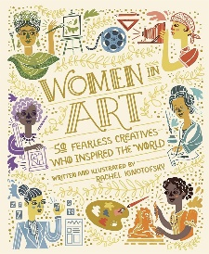  Portraits  Painting and mixed media  Colour  Pattern
Year 6 | Photo opportunity  Craft and design  Colour  Pattern |  | Expressing ideas  Drawing  Line  Texture |  | Making memories  Sculpture and 3D  Line

