 | Autumn 1 | Autumn 2 | Spring 1 | Spring 2 | Summer 1 | Summer 2
Topic  Title  Children’s interests will be followed as and when they arise. | Me and My Family  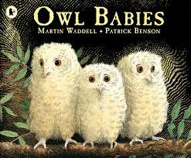  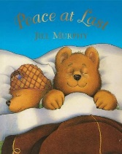 | My Celebrations  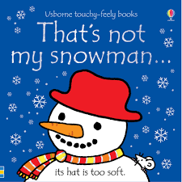  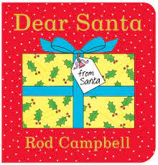  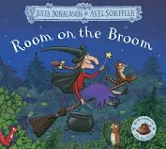 | 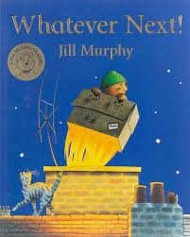  My Journeys  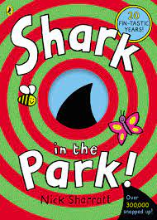 | Animals Around Me  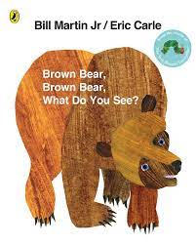  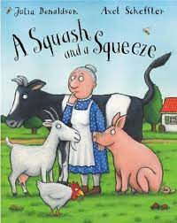  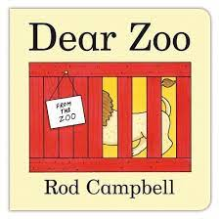 | Come Outside!  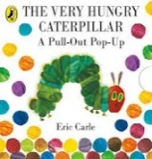  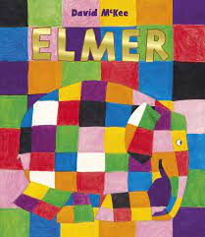 | 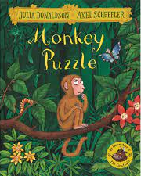  Special People  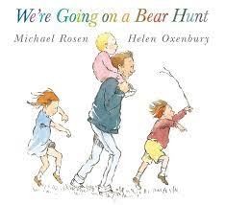
Intended Themes | My face & body  Me & my family  Me & my new friends | My celebrations  How I Celebrate  Transition to Nursery | My journeys  Places I go  How I travel  Me & my new friends | Me and my pet  Looking after our pets  Animals around me  Simple animal facts  Transition to Nursery | Plants and growing  Taking care of our garden  How do we dress for Summer?  Me & my new friends | Who are my special people?  What makes me special?  Who helps me to stay safe?  Transition to Nursery
Experiences | Visit from Santa |  | Visit from story teller |  | ‘Into the Wild’ Experience
Vocabulary Focus | See vocabulary document
Festivals / Celebrations | Birthday Celebrations  Autumn Walk | Birthday Celebrations  Halloween  Bonfire Night  Christmas | Birthday Celebrations  Winter Walk  Chinese New Year  Storytelling Week | Birthday Celebrations  Spring Walk  World Book Day  Shrove Tuesday  Mother’s Day  Easter | Birthday Celebrations  Summer Walk | Birthday Celebrations  Father’s Day  Art Week
Parents as Partners | Transition from home  Two-Year-Old Progress Check  50 things to do…  Core Story Sacks | Stay and Play – Christmas Crafts  Christmas Sing-A-Long  Graduation Ceremony  50 things to do…  Core Story Sacks | Transition from home  Two-Year-Old Progress Check  50 things to do…  Core Story Sacks | Stay and Play - Easter Crafts  Graduation Ceremony  50 things to do…  Core Story Sacks | Transition from home  Two-Year-Old Progress Check  50 things to do…  Core Story Sacks | Stay and Play – Teddy Bears Picnic  Graduation Ceremony  50 things to do…  Core Story Sacks
Key Knowledge | Naming parts of my face and what they do  Know who lives in my house  Know who is special to me  Know the names of new friends and teachers.  To remember daily routines  Communicate my likes and dislikes  Talk about something I did in the past (yesterday, last week)  Explore and talk about different weather | Know how I celebrate different occasions e.g. having a birthday cake with candles, receiving an Easter egg, wearing special clothes.  Talking about special times for me and my family, e.g. visit from Grandma, weddings birth of a baby etc  Explore and talk about different weather | Places I go, what do I do there  My local area – what do we see?  How I get there  How I have grown and changed  How is outside changing? | Naming simple animals  What sounds do animals make?  Where do they live?  How is outside changing? | How do we look after our plants?  How have our plants changed?  How is outside changing?  Using senses outside  Name some natural things (tree, plant, garden etc) | Knowing who my special people are at home and at school (teachers and friends)  What is special about me  People in the community who help to keep us safe (police, firefighters, teachers, doctors and nurses)
Safety Focus | Road Safety (stop meaning stop)  Dressing for the Weather  Keeping ourselves safe and managing own risks (eating, climbing, walking inside etc)
Mathematics | To join in with simple rhymes with numbers  To say some number names  To compare amounts using ‘lots’ ‘more’ ‘same’  To use familiar language to describe a shape  To complete a simple inset puzzle  To notice a simple pattern in the environment  React to changes of amount in a group up to three items  Compare sizes, weights etc. using gesture and language - ‘bigger/little/smaller’, ‘high/low’, ‘tall’, ‘heavy’  Develop counting-like behaviour, such as making sounds, pointing or saying some numbers in sequence.  Count in everyday contexts, sometimes skipping numbers – ‘1-2-3-5’.
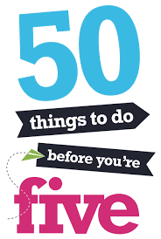  50 Things to do Before You’re Five | #3 Treasure Time  #5 Squidgy Sand  #8 Bubbles! | #22 My Secret Treasures  #21 Gigglebox  #33 Home From Home | #12 Brrrr, Explore the Cold  #29 Pitter Patter  #42 The Rough and the Smooth | #4 Make Your Mark  #31 Boing! | #20 Mini Artists  #32 Where Have I Gone? | #26 Splish, Splash, Splosh!  #45 Wonderful Waiting Games
Carrwood Primary School – Two Year Old Curricular Goals
Communication and Language – Confident Communicators | Ask for help when I need it  Tell someone what I am doing  Listen when somebody says my name  Apply words to objects
Personal, Social and Emotional Development | Help others understand how I am feeling  Confident to talk to others  Show resilience when leaving key adults
Physical Development | Use a spoon to feed myself  Hold equipment with control  Ride a sit down trike  Walk up and downstairs safely  Wash and dry my own hands  Communicate my toileting needs and show some independence with personal care routines
Literacy | Enjoy sharing a book  ‘Read’ a book using some of my own words  Repeat words from my favourite stories  Enjoy making marks
Mathematics | Understand some number sequence, with support  Compare objects  Sing some number rhymes
Understanding the World | Remember the names of people special to me  Know my key adults  Explore playing in different weather  Be aware that things are different or the same
Expressive Art and Design | Create my own pictures  Name different colours  Perform the actions in familiar nursery rhymes

Petal’s Reading Diet
 | Autumn 1 | Autumn 2 |  | Spring 1 |  | Spring 2 | Summer 1 | Summer 2
Year Group Author | Rod Campbell  Including Dear Zoo, Noisy Farm, ABC Zoo, My Presents, It’s Mine! Farm 123, Oh Dear |  |  | Eric Hill  Including Where’s Spot? Spot Goes to School, Spot Bakes a Cake, Spot Goes to a Party |  |  | Jannie Ho  Animal ABC, Spring ABC, Vehicle ABC, Love ABC
Core English Texts | Owl Babies  Peace at last |  | Room on a broom  Dear Santa  That’s Not my Snowman | There’s a Shark in the Park  Whatever Next | Dear Zoo  Brown Bear, Brown Bear  A Squash and a Squeeze |  | The very hungry caterpillar  Elmer Little World: In the Forest |  | We’re Going on a Bear Hunt Monkey Puzzle
Non-Fiction Texts | Find out about Families (Lift the flap)  My family, your family |  | Birthday Counting | Indestructibles: Things That Go  My First Things That Go | Indestructibles: Baby Animals  Easter Counting |  | Indestructibles: Let’s Go Outside |  | A Focus On: People Who Help Us
Traditional Tale Focus  (Know by Heart) | Goldilocks and the Three Bears, The Three Little Pigs, The Three Billy Goats Gruff, Little Red Riding Hood, The Gingerbread Man, Jack and the Beanstalk  (Ladybird Touch and Feel Texts)
Core Set of Poems & Rhymes | Wind the Bobbin Up  Round and Round the Garden |  | Row, Row, Row Your Boat  Incy Wincy Spider | I had a Tiny Turtle  See the Little Bunnies Sleeping | Humpty Dumpty  Baa Black Sheep |  | Twinkle Twinkle Little Star  Hickory Dickory Dock |  | Little Mousey Brown  See the Slippery Crocodile
Core Read Alouds  (read over and over again across the year) | Dear Zoo, Where’s Spot? That’s Not my Dragon, Each Peach Pear Plum, We’re Going on a Bear Hunt, Goldilocks and the Three Bears,  Meow, Roar (Non-Fiction), Eric Carle’s Twinkle Little Star and other Nursery Rhymes (Poetry Anthology)
Other Suggested Texts  (for the learning environment) | Eyes, Nose, Fingers and Toes  This is the Bear  Mole’s Spectacles  Big Steps: We’re Having a Baby  Big Steps: I’m Starting Nursery  Big Steps: Can you Say Please?  What’s in your Tummy Mummy?  Whose Knees are These? |  | Cat’s Cookbook  Squirrel’s Snowman  My Hair  Big Steps: No More Tantrums  Big Steps: Let’s Brush our Teeth  Big Steps: Let’s Wash our Hands  The Very Hungry Caterpillar’s Birthday Party | Spot Goes on Holiday  Little Big Feelings: I Like to be Kind  Little Big Feelings: Sometimes I am Angry  Little Big Feelings: I Can Say Sorry  Little Big Feelings: When I am Happy  Little Big Feelings: When I am Sad | Hide and Seek Pig  Hide and Seek: Under the Sea  Hide and Seek: On the Farm  Hide and Seek: In the Forest  Hide and Seek with the Dinosaurs  Paddington’s Easter Egg Hunt |  | Garden Sounds  From the Garden  Usbourne – Pop up Garden  My World in 100 Words: My Garden |  | Postman Bear  Spot Goes to the Fire Station  Big Steps: We’re Going to the Doctor  Big Steps: We’re Going to the Dentist

